
Event:

SNCC INTERCLUB
Date:12 October 2025

Dear Interclub Riders

We are looking forward to seeing you tomorrow for the SNCC round of the 2025 Interclub Trophy.

The start list is attached. First rider off at 9:01am.

The address for HQ is

Little Gransden Village Hall
Primrose Hill
Little Gransden
SG19 3DP

It will be open from 8am and there is plenty of parking.

Please note it is about a 4.5km ride to the start. GPX route shared by email

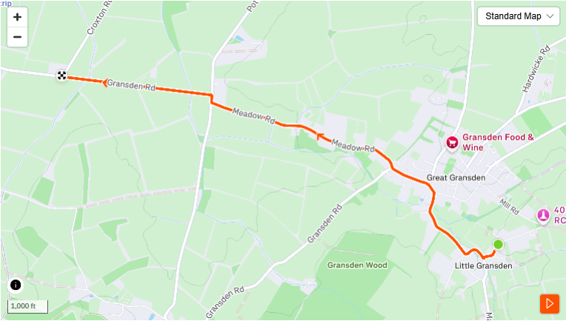

The course is one lap of the circuit - 11.2 miles/18 km. Course has been posted before but GPX also shared by email (start and finish location may not be exact).

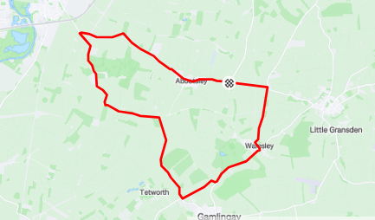

Tea, coffee and cake will be available afterwards at the HQ.

This is something of a special occasion for SNCC, as it is likely to be the last time we can ride our long-standing 'Abbo' course in it's current format - the ongoing A428 redevelopment will eventually result in some re-routing of the local roads at the far end of the course.

With that in mind, you do need to be aware of two sets of traffic lights which exist on the course - these are used to control site access, and are therefore not normally an issue during our race riding. That said, there is a chance that they can turn red, in which case you must obey the road traffic rules as you are required to do in any event at all times. As always, please ride with caution and don't take unnecessary risks.

Don't forget you need a suitable helmet and front and rear lights to ride.

We look forward to seeing out the 'Abbo' course with a flourish!

Regards
Nic & Justin

Any problems call 07941 032196

