

Hitchin Nomads CC – Interclub R1. 9am Saturday 27th June

Event Secretary - Colin Surrey – 07725 704487

Event Headquarters

Old Warden Village Hall, Biggleswade SG18 9HQ
There is plenty of parking. Please Park considerately.

Sign on: Opens at 8am & first rider off at 9.01
£5 cash entry on Sign on. We will accept Entry on the Line for this event (EoL).

Course details

4 laps of the Ireland Circuit @ 22.5mi
The start is 2.5mi from the HQ and is on the racing circuit.

The start & finish is along the straight road between the Bridge near the Black Horse Pub & going down towards Stanford. See the map.

The course is mainly al left turns with the EXCEPTION of the link road after the railway bridge before Keepers Warren that cuts off the triangular part. After the sharp turn at the apex of the triangle the course proceeds back passing the Black Horse Pub and bearing left over the bridge to repeat the lap. See the map.
https://www.plotaroute.com/route/2977605?units=miles

Road Safety

The course is in reasonable condition but there are some sharp turns and there may be some loose gravel at these. There are also some pot holes in the stretch after the junction with School Lane.

New and Recent Regulations

- All competitors must wear a HARD-SHELL Helmet that meets an international standard.
- FRONT & REAR LIGHTS –All competitors must have affixed a working white light and to the rear a working red light –both of which can be either flashing or constant in a position that is visible to other road users. NO LIGHTS = NO RIDE.
- You must SIGN IN and SIGN OUT.
- The results will be posted later on the Icknield Road CC weblink.

Other Regulations

- Take care near Old Warden Village and look out for other road users.
- NO U-turns should be made in sight of the start or finish areas. Competitors, supporters and officials must use the toilet facilities at the HQ.
- NO cars – other that of the timekeepers and officials must be parked in the vicinity of the start or finish areas.

Categories of Machines

For the Interclub all machines are grouped together. However individual clubs may wish to record which machines are ridden. All road bikes must comply with the new CTT Regs: No tri or clip on bars; wheels must have at least 12 spokes & max depth of 90mm & no disc wheels.

The Course:

https://www.plotaroute.com/route/2977605?units=miles
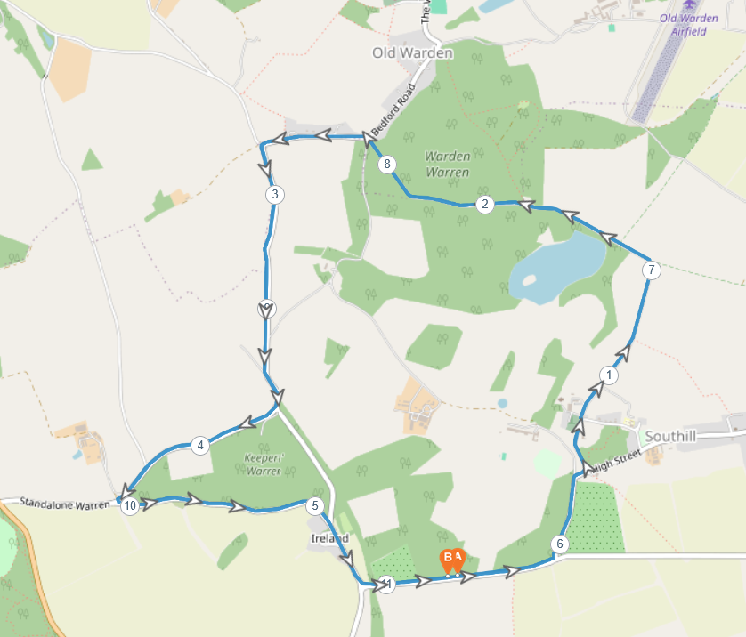
To the Start from HQ – 2.5mi.
https://www.plotaroute.com/route/3353617?units=miles

